Project link (Github): <https://csumb-sarah-pennington.github.io/final/index.html>

Summaries:

Recycling and what problems come with it, such as misinformation. We want to focus on the truth in recycling. How different products can be reused and recycled for multiple uses in comparison to single use-plastics that just sit in landfills after being “recycled.” We want to educate on the topic and explain what and how things get truly recycled and not thrown into landfills.

We will be including the reality of recycling, contributions, and education on the topic. Specifically how most of our “recyclables” end up in landfills and in the ocean. Imaginative recycling will also be discussed and how imagining something is recyclable when it is not is actually worse for the environment. Affected marine life will also be a topic as well as its effects on humans due to the consumption of microplastics. We will be discussing possible solutions and policies to implement to make recycling easy such as biodegradables.

Some of the challenges we faced were the navbar and footer, some styling elements we wanted to include (specifically with the text), and uploading the project to GitHub. We overcame these obstacles by working together and a little help from Google. Overall our project came out the way we wanted and we’re super proud of it!

**Color Palette and Typography:**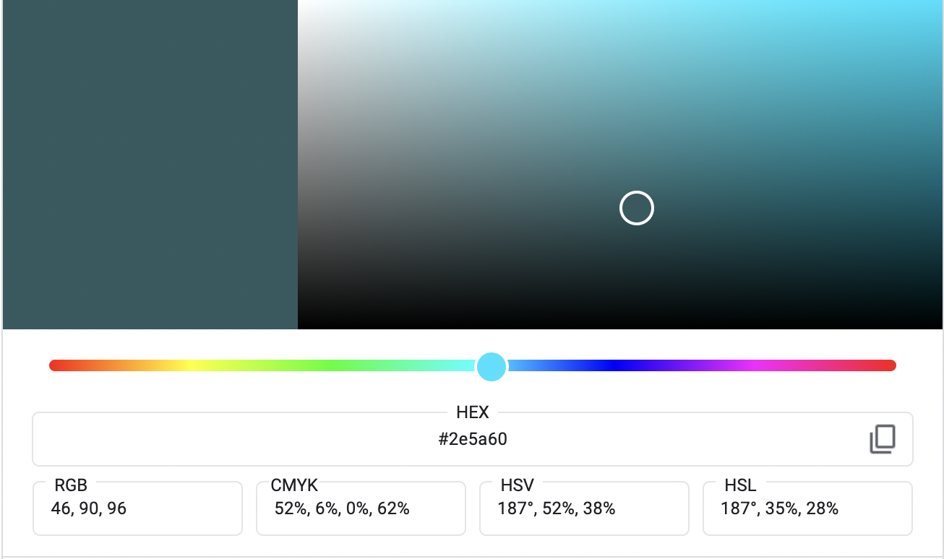

We used this color along with white as its partner color.

We also used Mencken

### Designed by [Jean François Porchez](https://fonts.adobe.com/designers/jean-francois-porchez) from adobe fonts. Along with Proxima Nova to use on our body text.

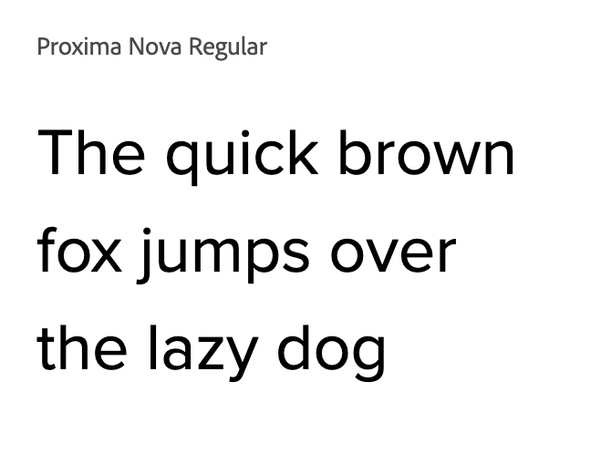

Example pieces:

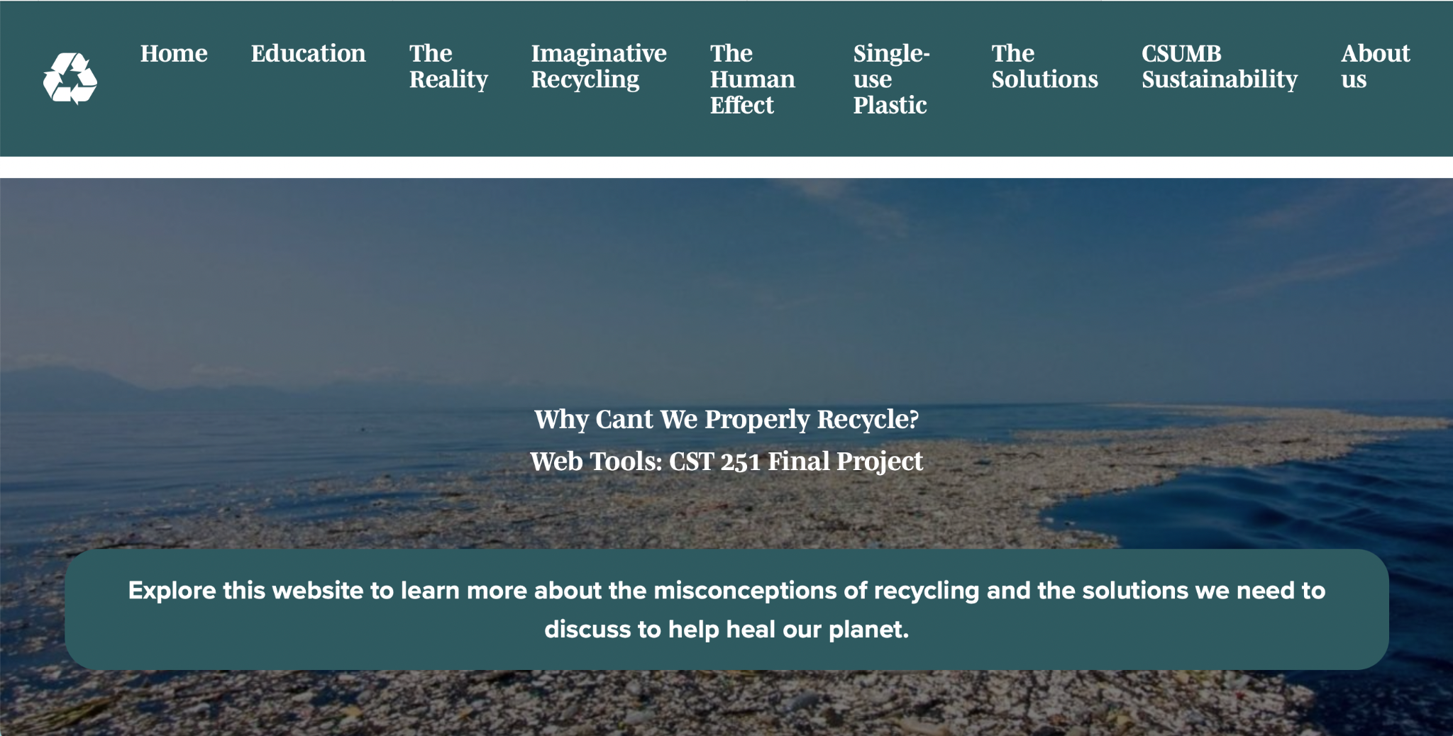

Our Hero Page

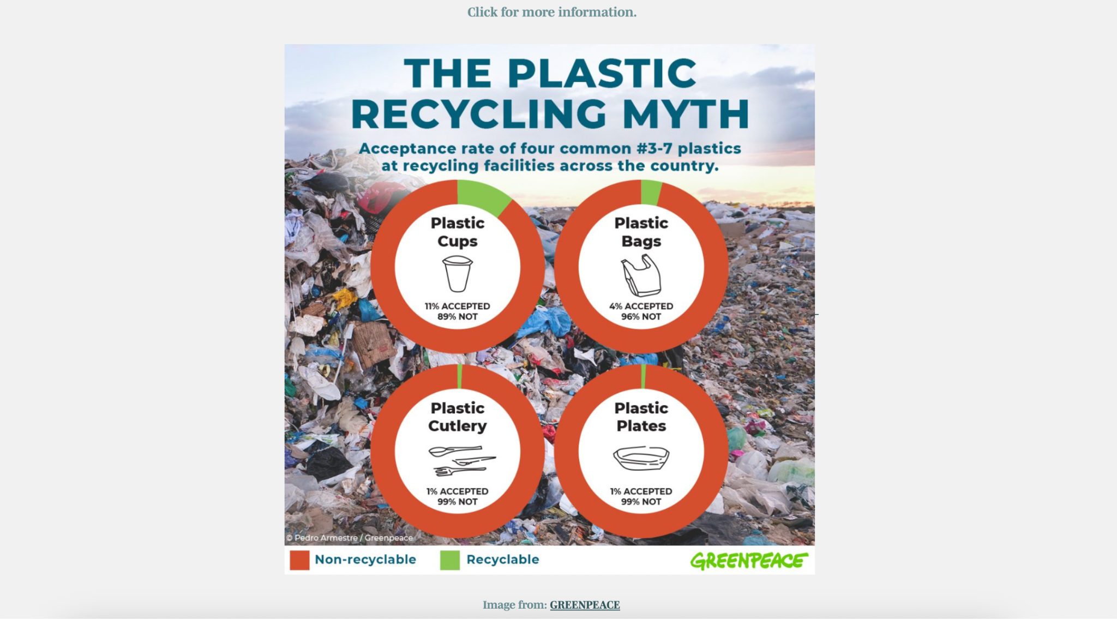

The image expands when hovered on!

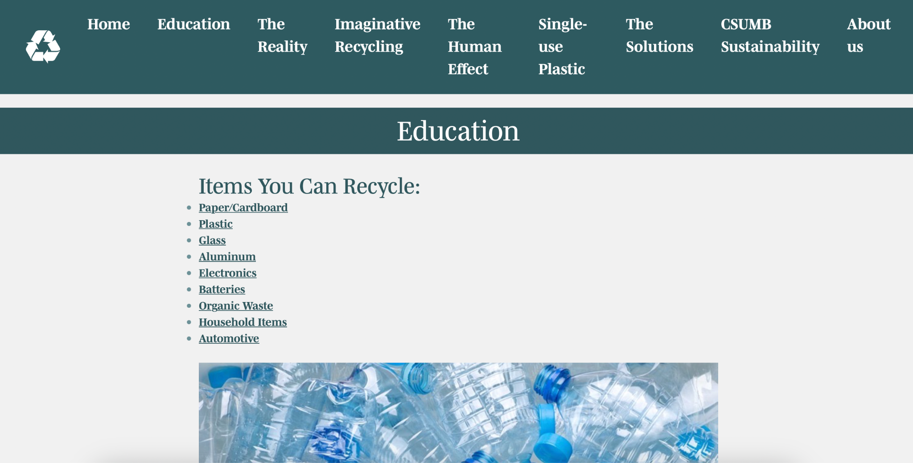

Carousel of educational images.

Personal W3 Validator Screenshots:

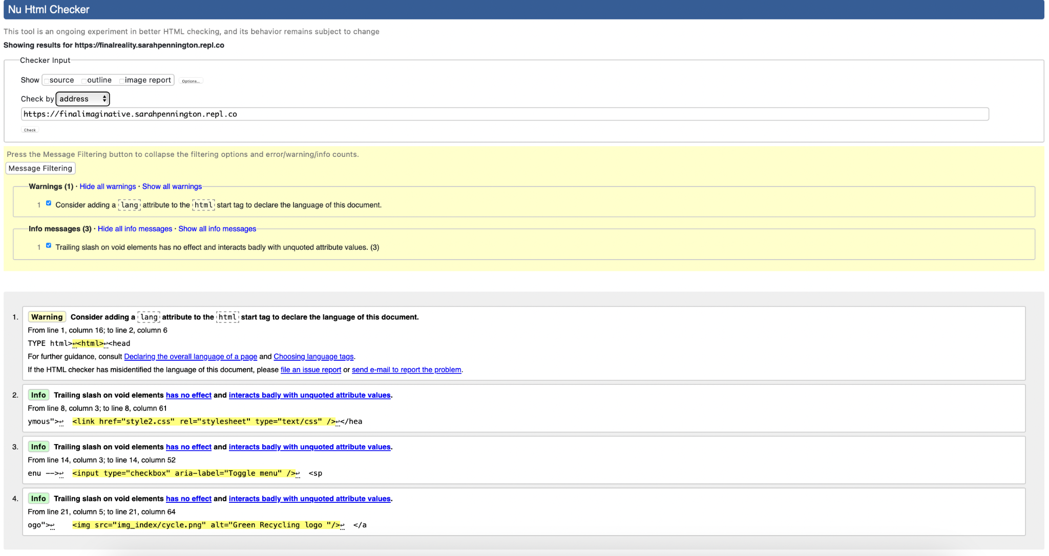

Validation of Imaginative Recycling page/Misinformation about Recycling. Originally only 1 error, but it is now corrected.

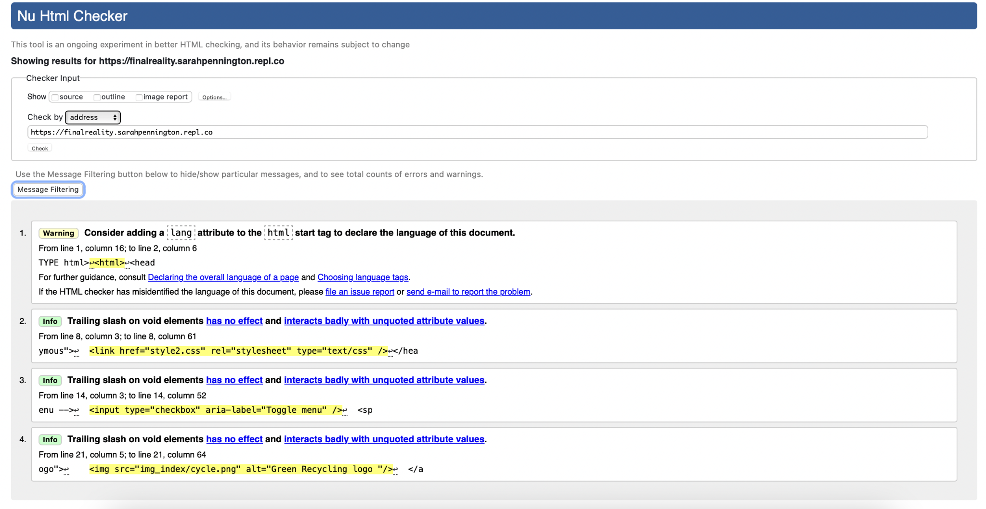

Validation of Reality Page. Originally only 2 errors, but it is now corrected.